# Five9 Queued Voicemail (QVM)

Queued Voicemail (QVM)

Transferring a QVM Back to General Voicemail Queue

Returning to the Voicemail Page

Related Documents

**Description:** Information on Queued Voicemail (QVM) in Five9, including the process for agents to handle these call types.

 QVM is enabled for a limited number of skills. Consult your supervisor if you are unsure if your skill is included.

|  |
| --- |
| Queued Voicemail (QVM) |

When there is hold time, members are given the option to leave a voicemail for a return call. When an agent becomes available, the system will send the voicemail to the next available agent for handling.

The system will route the voicemail to an available agent. The agent will see a visual indicator of voicemail to **Accept** or **Reject** on the softphone.

**Note:** There is no audio notification of the voicemail. The softphone must always be visible, so make sure to structure your screens so that it is not covered by other browser windows.

 **Do not select Reject.** All voicemails will need to be accepted and processed as they come in like inbound calls.

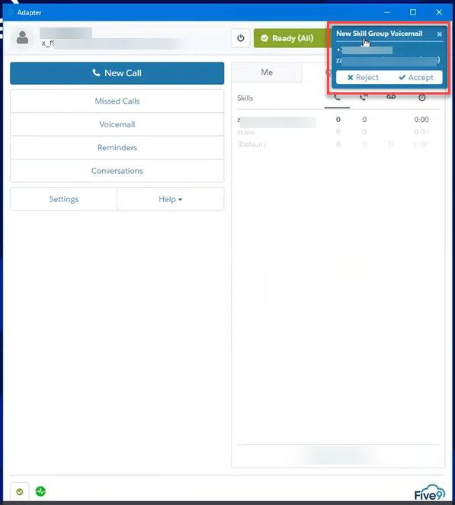

Follow the steps below:

|  |  |  |  |  |
| --- | --- | --- | --- | --- |
| **Step** | **Action** | | | |
| **1** | Select **Accept** to accept the voicemail.  **Result:** The voicemail is now assigned to you.  **Notes:**   * Once the agent accepts the voicemail, the voicemail stays with the agent until it is marked processed, moved to another agent, or sent back to the voicemail queue. * Accepted Voicemail should be worked with similar priority as an inbound call. | | | |
| **2** | Navigate to the 3 bars in the top left corner of the softphone, click the drop-down menu and select **Task Completion status**.    **Result:** Agent is no longer in a **Ready** state and will not receive a call when the voicemail is being worked.    **Note:** Once agent accepts the voicemail, they cannot select any other Not Ready Reason Code outside of **Task Completion** or log out of Five9. Agents **must** complete processing the voicemail before logging out of Five9 for lunch and/or end of shift.   * If attempting a logout before this is done, the below message will appear, preventing agent from completing the logout process. | | | |
| **3** | Listen to the voicemail (select **Play**).   * Select **Play**, **Stop**, or move the player scroll bar as needed. | | | |
| **4** | Confirm the phone number provided in the voicemail that the caller would like you to use.  **Note:** The phone number that the call was placed from is listed on the QVM. | | | |
| **If the phone number…** | **Then…** | | |
| Is the same (the number on the QVM matches what the caller has asked that you use) | Use the Call Back button on the QVM message.  **Note:** No selection of the Outbound Campaign is needed when the Call Back button is used as the system assigns it automatically to the skill that the call came in on.  Per legal requirements on telephone solicitation, only call the member back between the hours of 8 AM and 8 PM the local time of the member’s location. Do not call the member back on Sundays or Holidays without supervisor approval. Refer to the call handling policy document for your line of business. | | |
| **If the callback is...** | **Then...** | |
| Answered | 1. Follow standard outbound call process when completing the callback, which includes but may not be limited to:   * Authentication * Verbally provide the recording disclaimer   **Examples:**   * As directed by the CIF * Consultative Call Flow for your line of business * HIPAA Grid for your line of business * Inbound or Outbound Call Quality Recording Disclaimer for your line of business   2. Complete documentation for the call in PeopleSafe/Compass and close the member’s profile.   * If a voicemail was left, notate the members profile with “Returned queued VM. No answer, left voicemail.” * If you were unable to access the member’s profile, no documentation is needed.   3. Proceed to Step 5. | |
| Not answered | 1. Leave the member a message explaining that you are returning their call.  **Do not** leave any PHI/PII on the message.  Good day, this is <your name> from <PBM Name> returning your call. I’m sorry I missed you, please call us back at the number on the back of your prescription insurance card at your convenience. Thank you.  2. Complete documentation for the call in PeopleSafe/Compass and close the member’s profile.   * If a voicemail was left, notate the members profile with “Returned queued VM. No answer, left voicemail.” * If you were unable to access the member’s profile, no documentation is needed.   3. Proceed to Step 5. | |
| Requested in the voicemail differs from what is captured on the QVM | Place the call back using the Manual Outbound call process:  1. Select the 3 bars in the top left corner of the softphone.    2. Select **Home** then select **New Call**.    **Note:** No selection of the Campaign needs to be made. The Caremark Manual Outbound campaign is the only campaign that will be visible and will be automatically selected. No agent action is needed.    **Result:** The phone number that is displayed on the receiver’s end is 623-228-9898.  3. Input the phone number and select **Dial**.  Per legal requirements on telephone solicitation, only call the member back between the hours of 8 AM and 8 PM the local time of the member’s location. Do not call the member back on Sundays or Holidays without supervisor approval. Refer to the call handling policy document for your line of business. | | |
| **If the callback is...** | | **Then...** |
| Answered | | 1. Follow standard outbound call process when completing the callback, which includes but may not be limited to:   * Authentication * Verbally provide the recording disclaimer   **Examples:**   * As directed by the CIF * Consultative Call Flow for your line of business * HIPAA Grid for your line of business * Inbound or Outbound Call Quality Recording Disclaimer for your line of business   2. Complete documentation for the call in PeopleSafe/Compass and close the member’s profile.   * If a voicemail was left, notate the members profile with “Returned queued VM. No answer, left voicemail.” * If you were unable to access the member’s profile, no documentation is needed.   3. Return to the QVM message. Refer to Returning to the Voicemail Page. |
| Not answered | | 1. Leave the member a message explaining that you are returning their call.  **Do not** leave any PHI/PII on the message.  Good day, this is <your name> from <PBM Name> returning your call. I’m sorry I missed you, please call us back at the number on the back of your prescription insurance card at your convenience. Thank you.  2. Complete documentation for the call in PeopleSafe/Compass and close the member’s profile.   * If a voicemail was left, notate the members profile with “Returned queued VM. No answer, left voicemail.” * If you were unable to access the member’s profile, no documentation is needed.   3. Return to the QVM message. Refer to Returning to the Voicemail Page. |
| **5** | Navigate back to the Five9 softphone and select **Mark Processed** at the bottom of the screen.  **Result:** The following screen is displayed.    **Note:** Once the agent marks the voicemail as processed, they cannot go back to access the voicemail. Reach out to your supervisor to retrieve a processed voicemail and/or re-forward a voicemail if needed. | | | |
| **6** | Select **Go Back** at the bottom of the screen or navigate to the home screen and then change your state appropriately. Refer to the **Changing States** section of [Compass - Five9 Agent Desktop Softphone (056045)](https://thesource.cvshealth.com/nuxeo/thesource/#!/view?docid=ad8f7284-fee0-4ae1-bbbd-d2cbe07a331f).    The accepted voicemail must be processed before logging out of Five9 (for lunch and/or end of your shift). Always make sure that you open an RM Task before marking processed should you need to step away and log out or move to a Not Ready state.   * The below message will appear preventing you from completing the logout process. | | | |

Top of the Document

|  |
| --- |
| Transferring a QVM Back to General Voicemail Queue |

Five9 can transfer a QVM back to the originating skill if needed.

**Note:** This should only be used on rare occasions when you are unable to complete processing an accepted QVM before signing off (**Example:** Agent needs to leave work unexpectedly.).

Follow the steps below:

|  |  |
| --- | --- |
| **Step** | **Action** |
| **1** | Ensure you are in a **Task Completion** status prior to starting the transfer process. |
| **2** | While on the voicemail screen, select the arrow pointing to the right box. This is the transfer button for QVM. |
| **3** | On the Transfer screen, type in the name of the Skill to Transfer the QVM to, then select the skill.  Voicemails should only be transferred to the same skill that they came in on.    If unsure of which skill to input, reach out to your supervisor to confirm. You can also consult the skills assigned to you on your softphone. To do so, navigate to the top left of the softphone and click on the 3 bars and select **Home**. You can view your skills under the “Queue” tab.    **Result:** The **Complete Transfer** button becomes enabled. |
| **4** | Select **Complete Transfer**. |

Top of the Document

|  |
| --- |
| Returning to the Voicemail Page |

To return to the Voicemail page follow the steps below:

|  |  |
| --- | --- |
| **Step** | **Action** |
| **1** | Click the 3 bars in the top left corner of the softphone and click **Home**.   * If you are already on the **Home** page, you will not see the 3 bars. Proceed to the next step. |
| **2** | Click the **Voicemail** icon on the **Home** page. |
| **3** | Select **Skill Group** on the top right of the screen.  **Result:** The voicemail player screen displays to begin reviewing the recording from.  **Note:** This screen may also contain personal voicemail, based on role and permissions. |
| **4** | Proceed to Step 5 in the QVM section and complete the process. |

Top of the Document

|  |
| --- |
| Related Documents |

[Five9 Customer Care Document Index (052307)](https://thesource.cvshealth.com/nuxeo/thesource/#!/view?docid=e696b7c2-078e-444c-a317-bf857986aa23)

[Customer Care Abbreviations, Definitions, and Terms Index (017428)](https://thesource.cvshealth.com/nuxeo/thesource/#!/view?docid=c1f1028b-e42c-4b4f-a4cf-cc0b42c91606)

**Parent Document:** [CALL 0049 Customer Care Internal and External Call Handling](https://policy.corp.cvscaremark.com/cs/groups/public/@pnp/@all/@6700/documents/sop/y2fs/bc0w/~edisp/call-0049.pdf)

Top of the Document

Not To Be Reproduced Or Disclosed to Others Without Prior Written Approval

**ELECTRONIC DATA = OFFICIAL VERSION / PAPER COPY = INFORMATIONAL ONLY**